Table of Contents
CaMOD Application Information 2
Overview 2
Project name 2
Project description 2
Current version 2
Related projects 2
Project Team 3
Government sponsor(s) 3
Development organization(s) 3
Project manager 3
Team members 3
SCM 4
Module name 4
Repository host 4
Repository root 4
Configuration items (code, docs, etc.) 4
Change control policy 4
Technology Stack 7
Infrastructure 7
Operating system 7
JDK/JRE version 7
Application container version 7
Database version 7
Software dependencies 7
Browser dependencies 7
Architectural Overview 7
High-level architectural diagram 7
Versions 8
Policy 8
Version history 8
Branches 8
Build and Deployment 9
Build Overview 9
Build tool (Ant, Maven, Make, other) 9
Build script 9
Build target (stage & prod) 9
Build parameters 9
Environment variables 10
Deployment 10
Deployment instructions 10
Post-deployment test cases 10

caMOD Application Information

Overview
caMOD allows researchers to submit and retrieve animal models of cancer. Researchers can contribute and retrieve model information, image constructs, and gene expression data by tumor location, diagnosis and genes.

Revision History
V2.0 | December 21, 2005
V1.3 | March, 2005
V1.2 | November, 2004
V1.1 | July, 2003
V1.0 | Feb, 2002

Project name
caMOD

Project description
caMOD allows researchers to submit and retrieve animal models of cancer. Researchers can contribute and retrieve model information, image constructs, and gene expression data by tumor location, diagnosis and genes.

Current version
1.3

Related projects

- cancer Images Data Portal (caIMAGE) – caIMAGE allows researchers to submit and retrieve histology images and annotations. Images and image annotations are submitted to a central repository and streamed for efficient access. Researchers can search images based on histology (tissue and diagnosis) and experiment information. Histology information is based on common terminology originating from the NCI Enterprise Vocabulary Server (EVS).

- Emice – Emice is the primary web site supporting the NCI Mouse Models of Human Cancers Consortium (MMHCC). The MMHCC is a collaborative program designed to derive and characterize mouse models, and to generate resources, information, and innovative approaches to the application of mouse models in cancer research

- caBIO – caBIO is an object-oriented infrastructure facilitating biomedical data integration. caBIO consists of object models defined using the Unified Modeling Language (UML). These UML representations are then implemented as middleware using Java 2 Enterprise Edition (J2EE) components, and the middleware is connected to a variety of intramural and extramural cancer research databases. caBIO is a web-services based infrastructure that provides uniform API access to a variety of genomic, biological, and clinical data source via Java, SOAP-XML, and HTTP-XML programmatic interfaces. caBIO is one of the key components of the NCICB core infrastructure known as caCORE. The caCORE 2.0 release (October 31, 2003) includes the caMOD object model (caMOD-OM), which is an object representation of caMOD.
- BIOgopher – BIOgopher is an ad hoc querying and reporting tool that enables researchers to integrate their local bioinformatics data with public bioinformatics data sources. In particular, BIOgopher presents a web-based, graphical user interface in which a user can build complex queries that incorporate data from any number of user-supplied Excel spreadsheets. The results of such queries are then delivered to the user as an Excel spreadsheet in which the user's data and the public data are merged. BIOgopher is an important laboratory tool supporting data integration via a user-friendly environment. By supporting Excel spreadsheets, researchers can continue to work with tools they are familiar with but obtain a much richer collection of critical data supporting analysis. BIOgopher is powered by caBIO and supports caMOD queries in the caCORE 2.0 release.

- caArray - The caArray data portal is a MIAME compliant data repository that allows submission of MIAME 1.1 level annotations and microarray data via web-based submission forms. Registration is required to submit data, or to access protected data.

Project Team

Government sponsor(s)
Mervi Heiskanen

Development organization(s)
SAIC

Project manager
Srini Guruswami

Team members
Sue Dubman (NCICB) Program Director
Mervi Heiskanen (NCICB) Project Lead
Fei Xu (NCICB) Cancer Model database curator
Sharon Settnek (NCICB/SAIC) Program Manager
Srini Guruswami (NCICB/SAIC) Project Manager
David George (NCICB/SAIC) Technical Lead
Ulli Wagner (NCICB/SAIC) Domain Expert
Nick Schroedl (NCICB/SAIC) Applications Developer
Sima Pandya (NCICB/SAIC) Applications Developer
Marc Piparo (NCICB/SAIC) Applications Developer
Clint Malone Web Developer

SCM

Module name
camod_dev

Repository host
cbiocvs2.nci.nih.gov.

Repository root
/share/content/cvsroot.

Configuration items (code, docs, etc.)
UML model
Design artifacts (UI, database)
Documentation
Source Code
JARs (libraries)

Change control policy
Changes to caMOD should be monitored since the following external applications have a dependency.

1. The MMHCC repository website http://mouse.ncifcrf.gov contains links to specific models in caMOD 2-tier. The links are built using the model id of specific models.
Example: The strain detail page for the Ink4a/arf knockout mouse http://mouse.ncifcrf.gov/available_details.asp?ID=01XB1 contains a link to caMOD: http://cancermodels.nci.nih.gov/mmhcc/searchResultsDetail.jsp?modelId=1636

We need to inform Dieter Naf (dnaf@ncifcrf.gov), Debbie Fitzgerald (dfitz@ncifcrf.gov), Kris Elspas (kxe@css.ncifcrf.gov) about the changes.

2. CMAP (Cancer Molecular Anatomy Project) http://cmap.nci.nih.gov
CMAP provides on its gene info pages links to caMOD data
Example: http://cmap.nci.nih.gov/Genes/GeneInfo?ORG=Mm&CID=222

The data are provided by the cabioop database. Data from DATOP had been copied to cabioop a long time ago. Cabio / CMAP should be prepared either to replace the data or how to build links in the caMOD n-tier data repository.

3. Emice website
The emice website contains links to specific queries in the mouse models part on the left menu bar. These links need to be replaced.
Example: http://emice.nci.nih.gov/mouse_models/organ_models/gastro_models contains link to http://cancermodels.nci.nih.gov/mmhcc/Search?modelName=&PInames=&organTissueName=Gastrointestinal+Tract+(MMHCC)&organTissueCode=C18875396,C18875408,C18875413,C18875415,C18875418,C18875417,C18875416,C18875420,C18875414,C18875419,C18875409,C18875410,C18875412,C18875411,C18875397,C18875399,C18875400&SpeciesKey=&search=+++Search+++

Several pages in the emice mouse models part contain links to specific gene information. The URL contains http://cancermodels.nci.nih.gov. We need to check if we are going to break anything when we introduce any changes to the application.
Example: Emice page http://emice.nci.nih.gov/emice/mouse_models/organ_models/gastro_models/murine_intestinal_neoplasia/models_colorectal_cancer
contains this link http://cancermodels.nci.nih.gov/mmhcc/caBIO/GeneInfoContainer.jsp?LLID=16653

Under "Submissions" is a link to the caMOD submission page http://emice.nci.nih.gov/emice/submissions. Verify that the link will work after we switched to n-tier.

4. Most website that link to caMOD 2-tier use this link http://cancermodels.nci.nih.gov/mmhcc/index.jsp We need to make sure that we redirect from this link to the new app.

5. The current (caBIO v3.0.1 & upcoming 3.1) “fully-integrated” caBIO / caMOD implementation poses many challenges. First of all, it has been difficult to synchronize the object models in these two systems as they evolve independently. Upgrades to caMOD system often result in improvements or changes to the object model, which will outdate the component under caBIO. Thus, managing configurations is difficult; end user will be led to different perspectives of the same data set. On the other hand, caMOD is loosely coupled with caBIO’s components thereby enabling us to easily adopt new revisions to caBIO.

To address this problem, the cleanest solution we propose is to de-couple caMOD’s object model from caBIO in a future release (post caBIO 3.1).

Technology Stack

Infrastructure

Operating system
Development: Windows (2000 & XP)
Deployment: Unix or Linix

JDK/JRE version
JDK/JRE 1.5.

Application container version
JBOSS 4.0.2

Database version
Oracle 9.2.0.6

Software dependencies
CSM 1.0.3
caBIO 3.0.1
caCORE 1.0.3
EVSTree 3.0.1

Browser dependencies
None

Architectural Overview

High-level architectural diagram

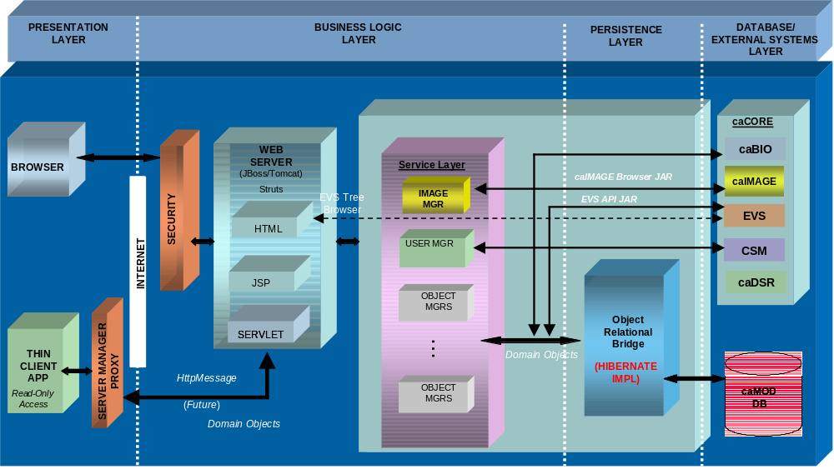

Versions

Policy
We follow NCICB policy as documented on the SCM Initiative Intranet site.

Version history

Version Number | Release date (production) | Change from previous version | Change Request(s) | Symbolic Tag
2.0 | TBD

Branches

N/A

Branch Tag | Root Tag | Parent Branch | Description | Owner | Policy | Merge Date | Merge Point Tag | Date Closed

Build and Deployment

Build Overview

Build tool (Ant, Maven, Make, other)
Ant

Build script
/build.xml

Build target (stage & prod)
clean-build-compile

Build parameters
/build.properties change jboss home location
/properties.xml specify appropriate database connection information
/src/hibernate.cfg.xml specify appropriate database connection information

/src/camod.properties

caArray, caImage and EVS should point to the appropriate serves in dev, stage, qa and prod.

# Coordinator username
coordinator.username=camod_demo

# EVS properties
evs.uri=http://cabio.nci.nih.gov/cacore30/server/HTTPServer

# Who to send new/update user requests to
user_settings.user_update_notify=georgeda@mail.nih.gov,georgeda@mail.nih.gov

# When a new uncontrolled vocab in entered
model.new_unctrl_vocab_notify=georgeda@mail.nih.gov,shandavegh@erols.com
model.new_unctrl_vocab_subject=A new uncontrolled vocabulary item has been added. Please see message body for details.

# CaArray integration
caarray.uri_start=javascript: alert('Note: You are now leaving the caMOD website'); myRef = window.open('http://cbiodev107.nci.nih.gov:29080/caarray/publicExperimentDetailAction.do?expId=
caarray.uri_end=','mywin','left=20,top=20,width=1200,height=700,status=1,scrollbars=1,toolbar=1,resizable=0');myRef.focus()

#caImage properties DEV
caimage.ftp.server=ncicbftp2.nci.nih.gov
caimage.ftp.username=lizupload
caimage.ftp.password=ncicblts
caimage.ftp.storagedirectory=Images/Model_Images/Model/

Environment variables
Java home set to JDK1.5

Deployment

Deployment instructions
CSM Configuration: Please follow steps in the CSM documentation. For clarification or issues contact the CSM team or caMOD team

Post-deployment test cases

Launch caMOD from a browser, login and click on search. You’ll get a table with the model name, organ name (from EVS) and species.

Then, make sure there are no stack traces or exceptions in the log.

